**Chapter- 1**

**Introduction**

1.1 Overview

Java is the foundation for virtually every type of networked application and is the global standard for developing and delivering embedded applications, games, web content, and enterprise software. Used by more than 12 million developers worldwide, Java enables you to efficiently develop and deploy exciting applications and services.

**1.2 Historical development**

Since 1995, Java has changed our world and our expectations.

Today, with technology such a part of our daily lives, we take it for granted that we can be connected and access applications and content anywhere, anytime. Because of Java, we expect digital devices to be smarter, more functional, and way more entertaining.

In the early 90s, extending the power of network computing to the activities of everyday life was a radical vision. In 1991, a small group of Sun engineers called the "Green Team" believed that the next wave in computing was the union of digital consumer devices and computers. Led by James Gosling, the team worked around the clock and created the programming language that would revolutionize our world – Java.

The Green Team demonstrated their new language with an interactive, handheld home-entertainment controller that was originally targeted at the digital cable television industry. Unfortunately, the concept was much too advanced for the team at the time. But it was just right for the Internet, which was just starting to take off. In 1995, the team announced that the Netscape Navigator Internet browser would incorporate Java technology.

Today, Java not only permeates the Internet, but also is the invisible force behind many of the applications and devices that power our day-to-day lives. From mobile phones to handheld devices, games and navigation systems to e-business solutions, Java is everywhere!

1.3 Basic principles and concept

# Java OOPs Concepts

1. Object-Oriented Programming
2. Advantage of OOPs over Procedure-oriented programming language
3. Difference between Object-oriented and Object-based programming language.

In this page, we will learn about the basics of OOPs. Object-Oriented Programming is a paradigm that provides many concepts such as inheritance, data binding, polymorphism, etc.

Simula is considered the first object-oriented programming language. The programming paradigm where everything is represented as an object is known as a truly object-oriented programming language.

Smalltalk is considered the first truly object-oriented programming language.

The popular object-oriented languages are Java, C#, PHP, Python, C++, etc.

The main aim of object-oriented programming is to implement real-world entities for example object, classes, abstraction, inheritance, polymorphism, etc.

## OOPs (Object-Oriented Programming System)

Object means a real-world entity such as a pen, chair, table, computer, watch, etc. Object-Oriented Programming is a methodology or paradigm to design a program using classes and objects. It simplifies the software development and maintenance by providing some concepts:

* Object
* Class
* Inheritance
* Polymorphism
* Abstraction
* Encapsulation

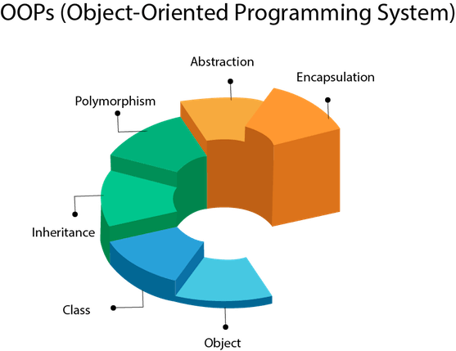

Figure-01 Object Oriented Programming System.

## Object

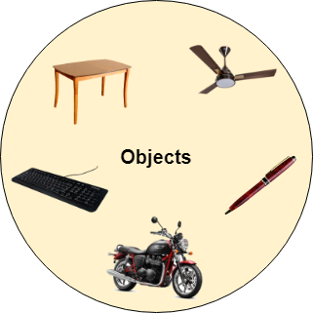

Figure-02 Object Oriented concept.

Any entity that has state and behavior is known as an object. For example, a chair, pen, table, keyboard, bike, etc. It can be physical or logical.

An Object can be defined as an instance of a class. An object contains an address and takes up some space in memory. Objects can communicate without knowing the details of each other's data or code. The only necessary thing is the type of message accepted and the type of response returned by the objects.

Example: A dog is an object because it has states like color, name, breed, etc. as well as behaviors like wagging the tail, barking, eating, etc.

## Class

Collection of objects is called class. It is a logical entity.

A class can also be defined as a blueprint from which you can create an individual object. Class doesn't consume any space.

### Inheritance

When one object acquires all the properties and behaviors of a parent object, it is known as inheritance. It provides code reusability. It is used to achieve runtime polymorphism.

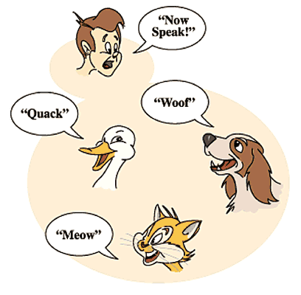

Figure-03 Inheritance concept.

### Polymorphism

If one task is performed by different ways, it is known as polymorphism. For example: to convince the customer differently, to draw something, for example, shape, triangle, rectangle, etc.

In Java, we use method overloading and method overriding to achieve polymorphism.

Another example can be to speak something; for example, a cat speaks meow, dog barks woof, etc.

#### Abstraction

Hiding internal details and showing functionality is known as abstraction. For example, phone call, we don't know the internal processing.

In Java, we use abstract class and interface to achieve abstraction.



Figure-04 Abstraction concept

### Encapsulation

Binding (or wrapping) code and data together into a single unit are known as encapsulation. For example, capsule, it is wrapped with different medicines.

A java class is the example of encapsulation. Java bean is the fully encapsulated class because all the data members are private here.

## Advantage of OOPs over Procedure-oriented programming language

1) OOPs makes development and maintenance easier whereas in a procedure-oriented programming language it is not easy to manage if code grows as project size increases.

2) OOPs provides data hiding whereas in a procedure-oriented programming language a global data can be accessed from anywhere.

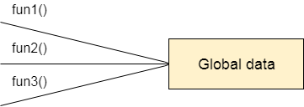

Figure-05 Data Representation in Procedure-Oriented Programming

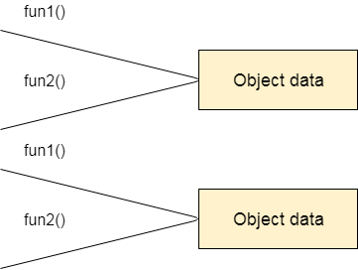

Figure-06 Data Representation in Object-Oriented Programming.

3) OOPs provides the ability to simulate real-world event much more effectively. We can provide the solution of real word problem if we are using the Object-Oriented Programming language.

1.4 Applications

**Desktop Based Application:** -In desktop-based application we use a java library were some method and objects are required frequently so in the intention to increase the reuse-ability and flexibility of code and increases the performance of system.

**Web Based Application: -** web based application uses the java library for archiving same goal which are written in above statement.

**Chapter- 2**

**Literature Review**

2.1 Recent developments

**Frameworks** are large bodies (usually many classes) of prewritten code to which you add your own code to solve a problem in a specific domain. Perhaps you could say that the framework uses your code because it is usually the framework that is in control. You make use of a framework by calling its methods, inheritance, and supplying "callbacks", listeners, or other implementations of the *Observer* pattern.

**Constrast to library**. Although sometimes large libraries are referred to as frameworks, this is probably not the most common use of the term.

The distinction between *framework* and *library* is defined quite well in *Patterns and Software: Essential Concepts and Terminology*.

The difference between a framework and an ordinary programming library is that a framework employs an inverted flow of control between itself and its clients. When using a framework, one usually just implements a few callback functions or specializes a few classes, and then invokes a single method or procedure. At this point, the framework does the rest of the work for you, invoking any necessary client callbacks or methods at the appropriate time and place. For this reason, frameworks are often said to abide by the Hollywood Principle ("Don't call us, we'll call you.") or the Greyhound Principle ("Leave the driving to us.").

## Usefulness of frameworks

A framework will often dictate the structure of your application. Some frameworks even supply so much code that you have to do very little to write your application. This can be good or bad, depending on how easy it is to use. As Wil Shipley says: Frameworks are the substance of programming. You build on top of a good one, your program is solid and fast and comes together beautifully. You build on top of a bad one, your life is miserable, brutish, and short.

## Examples in Java

A very common example are GUI frameworks, eg Java's Swing and AWT classes. They have a huge amount of code to manage the user interface, and there is *inversion of control* because you start the GUI framework and then wait for it to call your listeners.

The Collections classes are sometimes called a framework, perhaps largely because of the size and complexity. But it is more properly referred to as a library because there is no inversion of control -- your programs simply calls methods in these predefined or extended classes.

**Basic GUI framework**? A criticism of Java is that a lot of explicit programming is still required to get even simple GUI programs running. There is a *Java Specification Request*, JSR 296: Swing Application Framework to lighten the programmer's burden.

2.2 Contributions from researchers

Oracle has two products that implement Java Platform Standard Edition (Java SE) 8: Java SE Development Kit (JDK) 8 and Java SE Runtime Environment (JRE) 8.

JDK 8 is a superset of JRE 8, and contains everything that is in JRE 8, plus tools such as the compilers and debuggers necessary for developing applets and applications. JRE 8 provides the libraries, the Java Virtual Machine (JVM), and other components to run applets and applications written in the Java programming language. Note that the JRE includes components not required by the Java SE specification, including both standard and non-standard Java components.

The following conceptual diagram illustrates the components of Oracle's Java SE products:

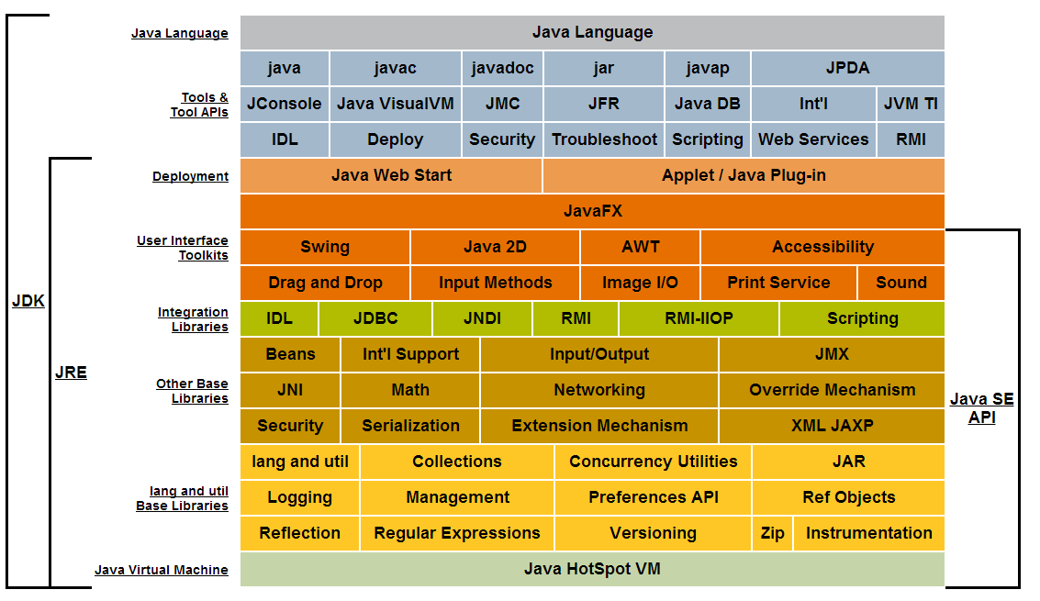

Figure-07 Description of Java Conceptual Diagram(api).

**Chapter- 3**

**Problem Identification**

3.1 General problems identified

### Unsecured: In normal java program data are not encapsulated by default, that’s why we mainly worry about security of java program, and it’s not a proper approach to develop a java project.

* **Redundancy:** When we need same code in different area on program our manly habit to write same code in each and every block of the code so which increases redundancy of the code.
* **Staticness:** Due to static behavior of normal java program if we need to change anything then we need to manually change the block every time.
* **Debugging issue:** when all the code in a same file then it’s difficult to debug, when an error is occurred in a program.

3.3 Objectives of the project

### a. Security

One of biggest advantages of using a framework is the security. An extensive framework will generally have security applications. If you are able to find a security hole or a vulnerability you can directly head towards the framework’s website. There the security issue can be fixed.

### b. Support

Generally, extensively used frameworks will have a large support group or large forums where one can have their issues resolved and questions answered. They also have documentation part where one can understand the framework.

### c. Efficiency

A general task can take you hours or days to complete with many lines of code. With the use of Java frameworks, these can be done pretty easily with the help of pre-defined functions. Therefore, the development becomes easier, quicker and effective.

### d. Expense

Generally, the maintenance cost of the framework is low. Also, most used structures are already present and help the developer to code faster. If the coding is done faster the expense will become smaller in every way be it time or effort.

**Chapter- 4**

**Methodology**

4.1 Procedures/steps in conducting the project

* In first step we need any operating system to create project.
* A text editor like Vim or Notepad.
* A Java Development Kit (JDK) version 8 or high.
* After understanding the basics of java api, we try to make an algorithm suitable to overcome repetative approch.
* Our main focus is GUI(java.awt and javax.swing packages) and JDBC(java.sql package).
* We got many methods for job done, but the problem is customization of method which provide the desired output.

4.2 Data collection

After brain storming and research on internet about the data which are used in database creation then we further processed in project.

4.3 Analysis/Design

**awt**

* Choose the elements which are required on that project like label, button, text field, combo-box, menu and radio button etc.
* After comparing the JFrame and JInteralFrame then we can conclude that JInternalFrame is batter than JFrame because with the help of JinternalFrame we can perform drag-in-drop, movement the window object, multiple frame, resizing, minimization and maximization operation very frequently.
* We are created menu bar of window object through we can easily select the menu item which we are required and also add a mnemonic on menu item.
* Action listeners are used to listen the action performed by buttons and combo-box.
* Window listeners are used for adjusting the width and length of current window.

**jdbc**

* In this phase we are downloaded jdbc driver for database connection from mysql.
* We make separate file for database connection which are required at the time of connection establishment to connect and then fetching and traversing data from database for preventing the repetitive working and the name of the file is DBLIB.java.
* At run time we provide the path of. Mysql jdbc driver and run them the code in very accurate way

4.4 Experimentation/validation

We are done the lots of experiments and validation on our project to check the flexibility, malleability, accessibility and reliability on our project.

We also use the collection framework instead of an array to gain the heterogeneous data with more appropriate manner without wasting the memory.

**Chapter- V**

**Results & Discussion**

5.1 Results of the project

The result of the project will be shown below the page in this figure is give brief explanation to generating generic form which are generated with the help of JinternalFrame on which according to input field the coordination of form are arranged itself and if the field of the form exceed the window then automatically form will be splits into two forms with next button.

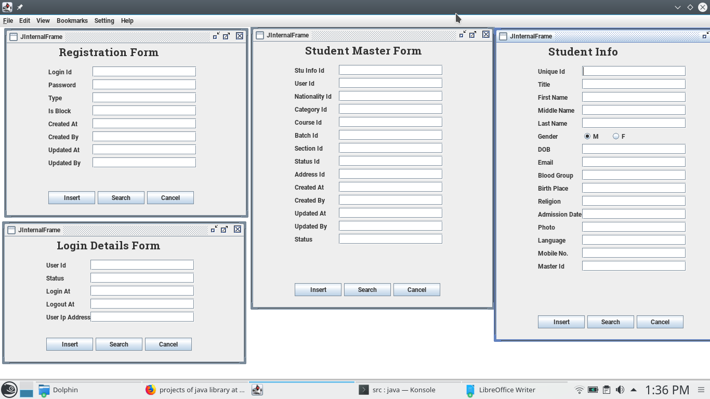

Figure-08 Generic form.

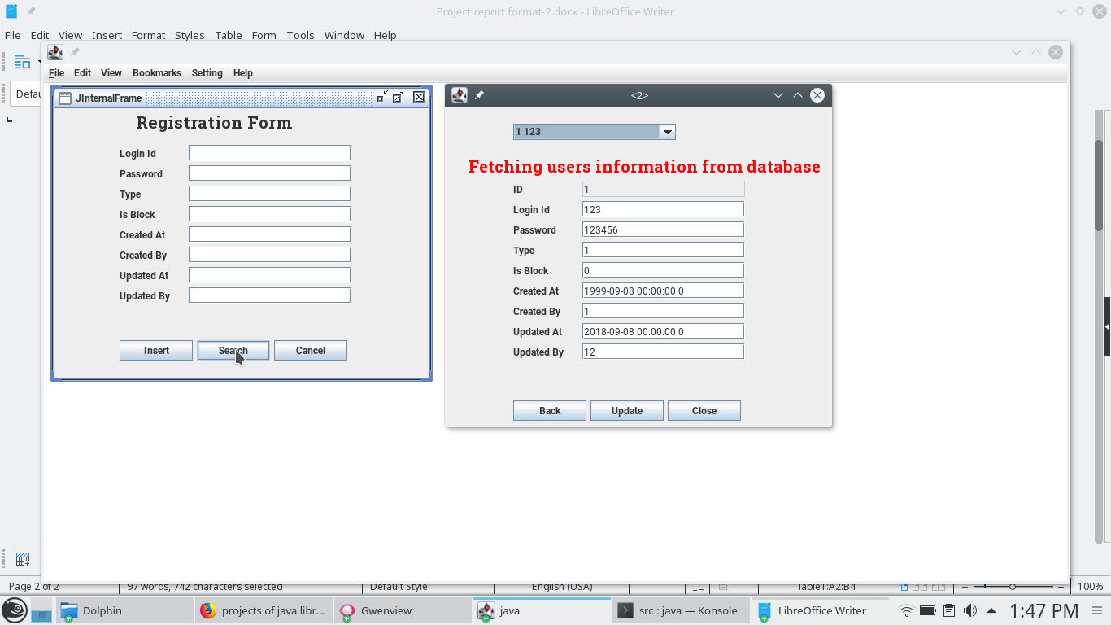

Here we wili show you the searching of particular entry from database through best optimal searching algorithm.

Figure-09 Searching Operation.

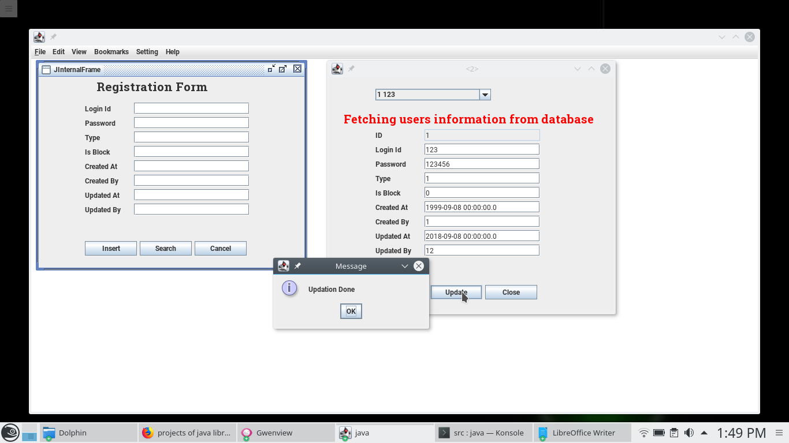

Figure-10 Updating Operation.

In this figure we will show you the updating process of any editable entry whenever we are required at any time with proper acknowledgment.

5.2 Analysis of the results

After performing the different type of testing on project at different angle and situation and according to the result we will make an analysis on them and come out an incursion that this type of project is acceptable at this level of education in current condition.

**Chapter- VI**

**Conclusion & Scope of future work**

6.1 Conclusions

Creating java library, based on the api of the java and implementing those libraries for performing many generic and special task with taking care of security major of the software and reduce the time and space complexity of the code with increasing the performance of the application.

After performing the different type of testing on project at different angle and situation and according to the result we will make an analysis on them and come out at the conclusion that this type of project is acceptable at this in competitive world and it is very useful for making application for future.

6.2 Scope for further work

In today’s competitive business world, organizations are struggling to stand first and get more benefits. In the world, Information technology is the one, which has held the first position for long years with many innovative trends. It has multiple stream and platforms to develop an application or product. When we talk of programming languages and technologies, Java is the most popular platform, which is used to develop several applications for the systems as well as embedded devices like mobile, laptops, tablets and many more. It is an object-oriented programming language and has a simple object model, as it has derived from C and C++. It provides a virtual machine, which is accumulated with byte-code and can run on any system.

Java is everywhere: on all platforms and devices and in all countries around the world. It enables developers to make programs work just about anywhere. And it inspired the evolution of an incredible technology community. The brilliance of Java is the platform independency. Thanks to the internet and the community spirit around it, so many people have been able to make a difference, earn a place in the spotlight with their own framework or tool, be recognized for their contribution, and really influence the Java world.

With time the importance and popularity of Java is on rise as it has the magic in its remarkable abilities to innovate and morph as the technology landscape changes. It is still the most pervasive platform, whether you want to use it for developing smart card applications, mobile applications, or server-side enterprise applications. One cannot think of any programming language with a more comprehensive set of APIs. It is a great language for beginners to start out with, and to continue across the curriculum. It is the language of choice for developing applications for the BlackBerry Smartphone.

Indian IT Industry: What is the future of Java and Java Jobs? Basically, Java is not just a Programming language but it is a programming atmosphere to develop and deploy enterprise applications. It is important for information technology industry to develop and create multiple web-based or server-based applications to enhance the industrial competency. There is huge scope for this programming language.

If one talks about job opportunities in field of Java, knowledge of it is required with many new technologies and roles such as ‘Java-UI Developers’, ’Android Developers’ and many others. Hence, there are numerous jobs opportunities available in Java, J2EE combining with other new technologies. These are among the higher paid jobs in IT industry, as it comes under software development. One should have the proficient skills to get an employment with IT organizations as many organizations are looking for the professionals, who can manage multiple projects in J2EE and augments the industrial efficiency.

In the screenshot below, let’s have a look at the data trends which shows how Java has dominated this field from early 2000’s till the present.

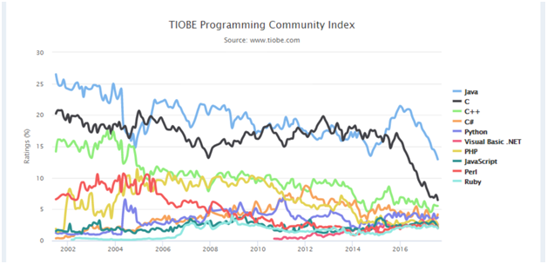

Figure-11 TIOBLE Programming Community Index.

As you can see in the above Java is widely used in the industry and is highly popular. Some of the different domains where Java is used widely are as follows:

* Financial services: It is used in server-side applications.
* Big Data: Hadoop MapReduce framework is written using Java.
* Banking: To deal with transaction management.
* Stock market: To write algorithms as to which company they should invest in.
* Retail: Billing applications that you see in a store/restaurant are completely written in Java.
* Android: Applications are either written in Java or use Java API.
* Scientific and Research Community: To deal with huge amount of data

#### Some of the technologies use java as a vital core of their functionalities.

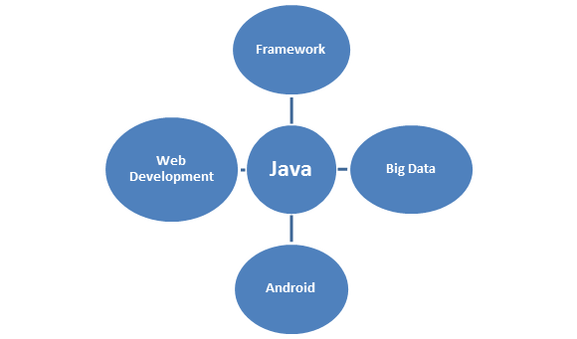

Figure-12 java functionalities.

Java is most widely used programming language. It is present everywhere. It is the ocean of opportunities. Whichever domain you work in you would surely come across Java Programming.

### Core Features of Java Programming

#### 1). Security:

Java is a secured language as there are no explicit pointers used and all the programs are run inside the sandbox to protect them from any un-trusted sources. Java develops a virus-free system and converts all the codes into bytecodes which are not easily readable by humans.

#### 2). Portable:

The key feature of Java is its portability as it can run on all the operating systems without any dependencies. Java is platform independent which means that any application written on one platform can be easily ported to another platform.

#### According to SUN Micro System:

Portability = Platform independent + Architecture

#### 3). Robust:

Java’s strong memory management system helps in eliminating errors by checking the codes during runtime. Java Programming is robust as it completely takes care of memory allocation and releasing.

#### 4). Object-oriented:

All the functions in Java are performed using objects. Thus Java is an object-oriented programming language. All these objects possess certain behavior. Hence, it is the most used language as it supports OOP’s concepts.

**Bibliography**

1. Kathy Sierra and Bert Bates, “Head First Java”, O'Reilly Media, Inc. 2nd edition, February 2005

# Bruce Eckel, “Think in java”, TIJ4, Fourth Edition, Published February, 2006

1. Ian Darwin, “Java Cookbook”, O’Reilly, First Edition June 2001, ISBN: 0-59600-170-3, 882 pages
2. <https://docs.oracle.com/javase/8/docs/api/>
3. <https://www.youtube.com/watch?v=eTXd89t8ngI&list=PLd3UqWTnYXOmx_J1774ukG_rvrpyWczm0>